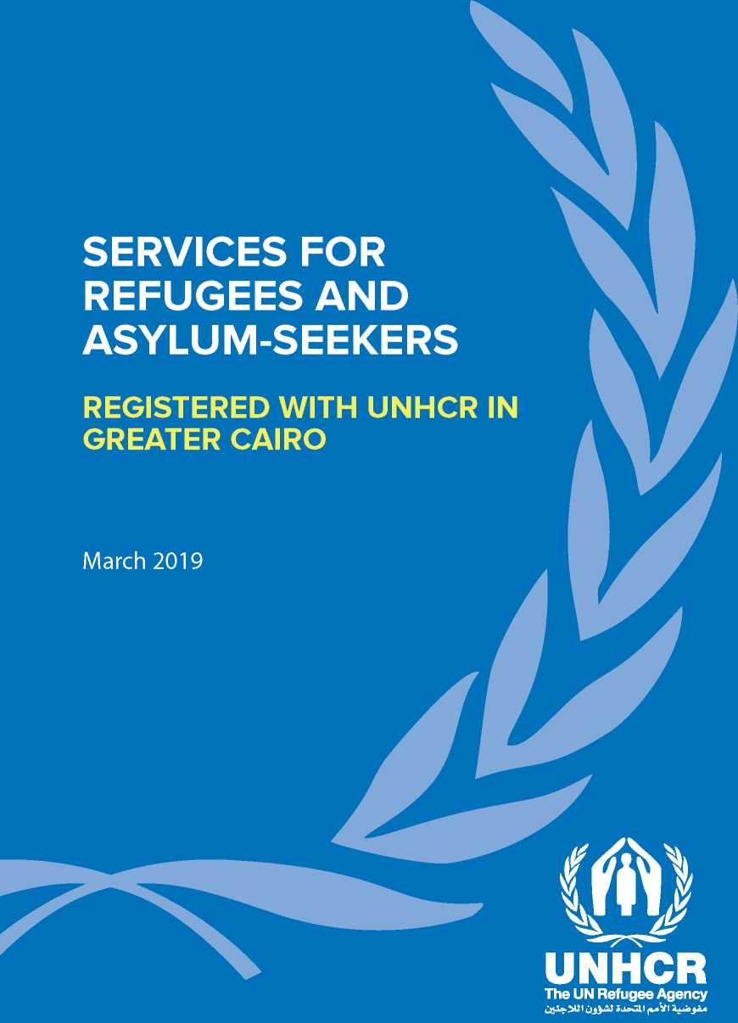

**USEFUL INFORMATION FOR REFUGEES AND ASYUM-SEEKERS**

Why register with UNHCR?

Registration allows you and your family to formalise your stay as asylum-seekers in Egypt. It also helps you with your daily interaction with Egyptian authorities and partners. In addition, registering with UNHCR facilitates residency and will protect you and your family from being returned to your counry of origin against your will.

When you register with UNHCR, you will be provided with a UNHCR registration document. Please pay attention to the validity of your UNHCR document and make sure you contact UNHCR for a renewal appointment one month prior to its expiration.

**UNHCR Registration Documents**

*I )*

This certificate is issued to persons registered with UNHCR who have officially applied for refugee status without presenting valid identification documents. It does not enable its holder to obtain a residency permit, but serves as proof of an asylum application in Egypt that is pending consideration for refugee status determination with the UNHCR Office, and based on which, he/she should be accorded international protection considerations. If you obtain identification documents after being issued a certificate, please approach UNHCR during reception hours to receive an Asylum­seeker Registration Card.

*I d)*

The card is issued to persons registered with UNHCR who have officially applied for refugee status and have presented valid identification documents. It provides protection from detention and deportation to your country of origin or any other country, and allows the holders to obtain a legal residence permit (sticker) to legalize their stay in Egypt. The card is valid for 18 months.

\ Refugee Registration Card (Blue Card)

The refugee registration card is issued to persons who had been formally recognized as refugees by UNHCR. The card allows its holder to obtain a legal residence permit (sticker) to legalize their stay in Egypt. It is valid for three years.

***J* UNHCR**

**Th» UH Mufaa Again**

**HOW TO CONTACT UNHCR?**

**UNHCR provides refugees with protection and assistance in coordination with the Egyptian Government and partners. Protection includes registration and documentation of asylum-seekers and referral to legal services.**

Refugees residing in the following governorates should approach UNHCR's reception centres in Cairo as indicated below:

Greater Cairo (Cairo, Giza, Helwan Assiut

Qalyubia) The Red Sea Sohag

Monofeya Fayoum Qena

North and South Sinai Bani Souwaif Luxor

Ismailia Sharkeya

Suez Menia

**Zamalek Registration Centre**

The Zamalek Registration Centre serves Syrian refugees.

To register with UNHCR or add family members to your file, you must call the UNHCR infoline to schedule an appointment.

Aswan

New Valley

**6th of October Reception Centre**

The 6th of October Reception Centre serves refugees of all nationalities apart from Syrian refugees.

To register with UNHCR or add family members to your file, you must come in person to schedule your appointment.

**UNHCR Egypt Infoline**

To schedule renewal or closure appointments and to receive answers about UNHCR services, please call the UNHCR Egypt Infoline.

**V. 02 2728 5699 O S^AVTiT"^**

**The Infoline answers calls daily in Arabic, English, Somali, Oromo,  
Tigrinya, Amharic and French.**

**SERVICES AVAILABLE AT RECEPTION CENTRES**

**New registration\***

***0 Sunday - Thursday***

***8:30 -13:00***

**Adding new family members (bring 2 photos)**

**Changing address or other data**

**Changing principal applicant or transfer to another case**

**Adding a new baby (bring 2 photos)**

**Closing or reopening your case**

**Requesting letters to authorities, schools and driver's licenses**

**Obtaining a Ministry of Foreign Affairs Closure number**

**WHAT DOCUMENTS TO BRING?**

**Please DO NOT FORGET to bring the following documents when coming to UNHCR reception centres:**

PLEASE PROVIDE ORIGINAL & COPY OF:

1. Passport(s)
2. All other available ID documents (military ID, driver's licenses, other civil documentation)
3. Marriage/divorce certificate(s)
4. Birth/death certificate(s)
5. Family booklets
6. High school or university diploma(s)/ Certificate(s)
7. Proof of previous registration with UNHCR in other countries (if applicable)
8. Two passport-sized photos of each family member on a white background

ALL UNHCR services are FREE of charge



**At NO point will you be asked to pay for any of the services provided by UNHCR or any of its partners.**

In cases where you have a reason to strongly believe fraud and/or corruption is taking place please submit a written complaint and drop it in a UNHCR complaint box, or send an email with your complaint to:

**[arecafrd@unhcr.org](mailto:arecafrd@unhcr.org)  
or  
[inspector@unhcr.org](mailto:inspector@unhcr.org)**

Procedures for Obtaining Residence Permit for  
Refugees and Asylum-seekers in Egypt  
Why do I need a valid residence permit?

**The importance of having a valid residence permit in Egypt:** Every foreigner, including refugees and asylum-seekers, staying in the Arab Republic of Egypt is obliged to have a valid residence permit. Without a valid residence permit, this foreigner would be staying illegally in the country, which is punishable under Egyptian laws. You could face legal proceedings, arrest and detention if you are found to be staying illegally in Egypt. Therefore, you are advised not only to obtain your residence permit after registration with UNHCR but also to renew it when it expires.

How do I obtain a residence permit in Egypt?

Steps to undertake to obtain the residence permit:

1. You should approach the Ministry of Foreign Affairs (MFA), located at Corniche El Nil, within a period of 21 days after receiving your UNHCR Registration card. At the Ministry, go to the Department of Refugees, located at the back gate of the Ministry of Foreign Affairs, where you will be provided with a reference number.
2. You must go the Residence Unit of the Immigration Department of the Ministry of Interior 21 days after approaching the MFA. You must take with you the reference number issued by the MFA.
3. The Unit in charge of residence permits for asylum-seekers and refugees is located at Mogamma Al-Tahrir, in Tahrir Square. You will be provided with a new reference number and an appointment to apply for the residence permit. On your appointment day, you will be requested to submit all necessary documents, including a one-page residence application form and a stamp for this application form.
4. Around 10 - 15 days later, as indicated by the officials of the Residence Unit, you will return to the Residence Unit of the Immigration Department of the Ministry of Interior , where you will obtain the legal residence sticker on your UNHCR card.
5. In case you entered Egypt irregularly or you lost your passport, the process might take longer.

**It is important that the principal applicant and his/her spouse be present at the Ministry of  
Foreign Affairs (MFA). After going to the MFA, go to the Mogamma to obtain the residence  
permit. Minor children are not required to attend.**

Documents required by the Mogamma:

1. All UNHCR issued registration cards of the family members and dependents registered with you in Egypt.
2. Original passport of the family members and dependents registered with you in Egypt.
3. Reference number which you obtained from the Ministry of Foreign Affairs.
4. Two passport-sized photos of your­self. Photos of your dependents are not needed unless they are 12 years old and above, and issued with a separate UNHCR documentation card.
5. Copies of both your passport(s) and your UNHCR issued registration document(s).

Are there any fees that I have to pay ?

The application form for the residence permit is available at the Immigration Department at Mogamma and is free of charge. You will only have to pay LE 20, at the bank located at Mogamaa, while presenting you application to the Residence Unit.

What type of residence permit will I be issued?

You will be granted with a regular legal non-tourist residence permit, for an initial period of 6 months, which will be renewable as long as you remain a person of concern to UNHCR in Egypt.

How do I renew my residence permit?

• The same steps and procedures should be undertaken to renew the residence permit. In this case, you will have to bring copies of the passport(s), UN registration card(s), one passport photo, and a copy of the previous residence permit. It is highly recommended to start renewing the residence permit four weeks prior to the date of expiry of the old one.

• The residence permit can only be completed at the Mogamma Al Tahrir in Cairo. You will need to be there to finalize all formalities, regardless of your area/city of residence in Egypt. and its partners in

PARTNERS AND SERVICES

In order to provide some services to refugees and asylum-seekers, UNHCR works with **implementing** and **operational** partners.

Implementing partners are funded by UNHCR, while institutions which do not receive funding from UNHCR, but who play a major role in refugee operations, are known as operational partners.

The opposite table provides the classification of partners:

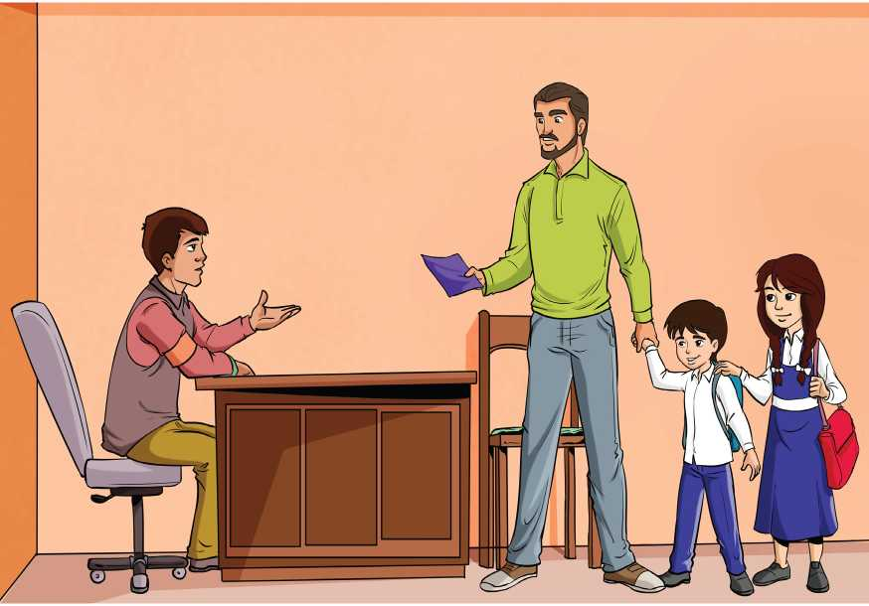

Q ®

Jx? UNHCR

**Th» UH Mufaa Again**

|  |  |  |
| --- | --- | --- |
|  | **Implementing Partners** | **Operational partners** |
| **Education** | mJIj_«.VIJ>_»II  *\S<* **X-I\J I EGYPTIAN RED CRESCENT**  **CATHOLIC RELIEF SERVICES '** | StA^4 |||  refugee services **Ford Foundotlon** |
| **Livelihoods** | $CRS LoM  **CATHOLIC RELIEF SERVICES**  **REFUGE W EGYPT** | (®  **c r-k-M** SALESIANI  **Save the Children** don **BOSCO** |
| **Cash Assistance** | Caritas  Egypt |  |
| **Health** | **REFUG^EGYPT**  PSTIC  MB ^Caritas  **Save the Children Egypt** |  |
| **Psychosocial** | PSTIC | >-  ***k MEDECINS SANS FRONTIERES* ^r!r** a^St^--  ***DOCTORS WITHOUT BORDERS* REFUGEE SERVICES** |
| **Legal Assistance** | **United Lawyers** | SiAFKs |
| **Community Centres** |  | KgB *  CjL)jqojj atulj **Faid Foundation** Souriyat Association |

EDUCATION GRANTS & SERVICES

Ministry of Education - Office of Foreign Students Affairs

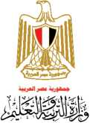The office is one of the central administrations affiliated with the Ministry of Education. It is concerned with setting policies for admitting foreign students into educational institutions.

Downtown

12, Falaky St., Bab El Louk

Catholic Relief Services (CRS)

UNHCR provides education grants through CRS that help finance education opportunities in Egypt at public, private, and community schools. In addition, CRS offers various educational activities such as Arabic and English language classes, turotiring assistance programme and vocational training.

(PcRS

**CATHOLIC RELIEF SERVICES**

Maadi

33, Street 106, Hadayek El Maadi (Metro: Hadayek El Maadi)

Education grant appointments & inquiries

**012 8500 3114**

Language classes & tutoring assistance registration & inquiries

**010 2111 3560**

**Sunday - Thursday**

**Catholic Relief Services Egypt**

**08:30 - 16:30**

Fard Foundation

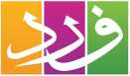Fard Foundation aims to provide individuals with access to high quality formal and informal education targeting school drop outs and refugee children.

2>j_9 q iu_Lug_o

Fard Foundation

6th of October City

Building 1, Block2/15, 12th District, Gharb Somid

**02 3838 4115**

**G Sunday - Thursday**

**Fardfoundation**

**09:30 - 16:00**

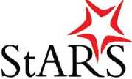St. Andrews Refugee Services (StARS)

SAINT ANDREW’S REFUGEE SERVICES

Offers various educational programs, including adult English and Arabic language courses, English courses in the Sudanese national curriculum from Grade 1 to Grade 12, information technology courses, sewing, handicrafts and henna drawing. It also supports communities in delivering quality education services.

Downtown

38, 26th of July St., Esaaf Square (Metro stop: Nasser)

**[info@stars-egypt.org](mailto:info@stars-egypt.org)**

**02 2773 6347**

**f St. Andrew's Refugee Services**

**G Monday - Thursday**

**9:00 - 17:00**

LIVELIHOOD SERVICES

Catholic Relief Services (CRS)

Supports refugees and asylum seekers who are interested in starting their own businesses. In order to be a part of the programme, you must be UNHCR-registered.

**$CRS**

Garden City

13, Ibrahim Naguib St.

**02 2794 8062**

**0101 006 1755**

Sunday - Thursday

09:00 - 15:30

**f Catholic Relief Services Egypt**

Plan International

Offers livelihood support to Syrian refugees in Cairo.

6th of October City - Head Office

114, 6th Tourist zone, opposite to Mall of Arabia,

6th of October City

El Hosary, 3rd District, next to Ouda Bank, Above Kheir Zaman Supermarket,

Haram

1 El Zawawy St., off Diaa St., 2nd floor.

10th of Ramadan City

7 ,17th District, in front of 5th District

**f Plan International Egypt**

**©Sunday - Thursday 10:00 - 15:00**

Offers livelihoods services through wage employment. Applicants receive essential work skills training and language courses.

Refuge Egypt

%

**REFUGE** WE

**EGYPT**

**i ministry of the Episcopal/Anglican Church**

Zamalek: All Saints Cathedral

5, Michel Lotfallah St., (behind Marriott Hotel)

012 0242 3147

**Monday - Thursday**

**09:00 - 16:00** *(Fridays and Sundays closed)*

**[www.refuge-egypt.org](http://www.refuge-egypt.org)**

Save the Children (SCI) Egypt

Offers literate adults (males and females aged 18 to 35) livelihoods services through wage employment. Applicants receive essential work skills training before job deployment. SCI also supports literate females, 18 to 35 years of age, who have micro-entrepreneurships, through training to support their projects.

**Save the Children**

Ard Ellewa

13, Mohamed Ali Al Eseiry St., Shohada St.

**Save the Children Egypt**

**©**

**Sunday - Thursday 09:00 - 17:00**

Don Bosco

Provides training experiences and modern techniques to get the highest level of technical education in order to develop skills and improve the chances to find a suitable job and build a successful future career.

SALESIANI

DON BOSCO

Sahel Shubra

2 Abdel Qader Taha St.

**012 0113 3874**

**[www.donboscocairo.org](http://www.donboscocairo.org)**

**©**

**Monday - Friday 13:00 - 19:00**

FINANCIAL ASSISTANCE

Caritas Egypt

UNHCR provides financial assistance to the most vulnerable. Please contact Caritas in Nasr City/ 6th of October for an assessment.

**Caritas**

W Egypt

Nasr City

A 30 Sibaweh El Masry Street off Anwar El Mofty, behind Moror Awel, Nasr City

**Appointments**

**011 2988 0899**

**012 8806 4703**

6th of October

Villa 574, Street 18, 3rd District, 3rd Proximity

**Appointments**

**011 2988 0800**

**Unaccompanied and separated children (UASC):** Following registration with UNHCR, you will be notified by UNHCR Child Protection Team (CP) on the same day about which CP agency will conduct your best interests assessment (BIA). Only after the BIA, you will be informed when you need to go to Caritas Garden City to process your financial assistance. Please make sure you do not miss your financial assistance appointment date; otherwise please inform your caseworker in advance.

Garden City Clinic

8, Abd El Latif Bolteya St., (formerly: Dar El Shefa St.), behind Four Seasons Hotel, next to Kasr El Nil Police station (For unaccompanied and separated minors only)

**02 2794 9203**

**Monday - Friday 08:30 - 12:00**

**02 2796 1771**

**02 2769 4441**

-1/1

**I /I UNHCR**

UPDATE YOUR CONTACT  
INFORMATION

**Please make sure you always update your contact information with UNHCR in case of changes**

You can do so by filling the form available at Window 4 in the UNHCR 6th of October Main Premises located in the 7th District

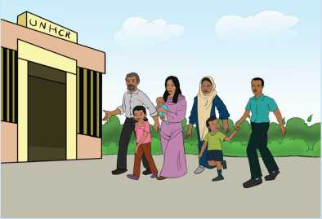

Or by contacting the UNHCR Infoline

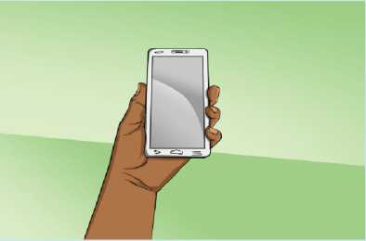

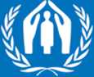

UNHCR

The UN Refugee Agency

**n in Arabic on:** @RefugeesEgyptAR **in English & other languages:** @RefugeesEgypt

HEALTH CARE

|  |  |
| --- | --- |
| **The Ministry of Health and Population (MOHP)** | |
| **The Ministry of Health and Population** (MOHP) provides subsidized primary and specialized health care through a variety of primary care clinics and specialized referrals. | |
| **Services Available at Public Primary Health care Centres** | |
| **Types of facilities** | **Types of services include:** |
| **Family Medicine and Health Centres** | **Maternal and Child Healthcare**  • Antenatal care (new and repeat visits)  • Postnatal care (new and repeat visits)  • Family planning  • Routine immunization for children  • Integrated management of childhood  illness |
|  | **Acute and chronic consultation**  • Lab services  • Dental care  • Chronic diseases  • Minor emergency services |
| **Health Offices** | **Registration and Issuing Certificates**  • Birth registration  • Birth certificate  • Death certificate |
| **Ambulance 123** | **Emergency 137** |

w

**I P'k UNHCR**

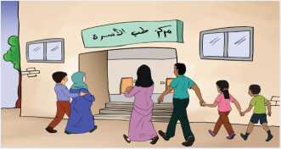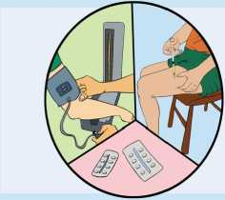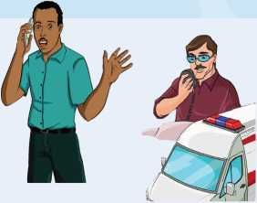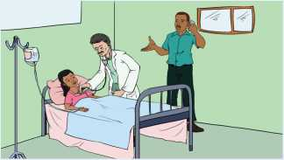

UNHCR

**The UN Refugee Agency**

Health Services for  
Refugees and Asylum Seekers in Egypt

**Do refugees and asylum seekers have acces to primary health care in Egypt?**

Yes, the Ministry of Health and Population provides preventative and curative health services including vaccination and pregnancy followup at the same rates as Egyptian citizens through various clinics, health offices and family medicine centers.

**What about refugees and asylum seekers with chronic diseases?**

Besides the public primary health care, refugees and asylum seekers with chronic conditions can have access to follow-up and treatment, as well through UNHCR which provides subsidized medical services with user contribution fees through its designated partners.

**What should I do when facing a medical emergency ?**

In case of emergency call MOH Public ambulance at 123 or 137. An ambulance car will reach you at the site and will transport you to the nearest accessible public hospital with available Intensive care or inpatient care beds. Proceed by contacting the emergency number of UNHCR partner who will visit you and assess the situation.

**Do refugees and asylum seekers have access to specialized health services and hospitalization?**

Yes, subsidized specialized health services and hospitalization with user contribution fees can be provided to refugees and asylum­seekers through UNHCR medical partners based on specific criteria.

HEALTH CARE

Save the Children (SCI) Egypt

**Save the Children** SCI works with the MOHP to improve access to quality health services for refugees.

In case of emergencies like accidents, burns, injuries, complicated deliveries, etc, call:

|  |  |
| --- | --- |
| **V.** | **Emergency Numbers 24 hours/ 7 days**  **010 6483 3320**  **012 80769456**  **012 80440146** |
| **PSTIC** | **011 0078 2000** (Available to non-Arabic speakers) |

If it is not an emergency that needs immediate help, please call the number for elective health services. This includes any health condition that does not need urgent intervention within 48 hours such as chronic kidney diseases including renal failure, cancer or the need for sssistive devices, etc. Note that for other chronic patients, they must be referred from other UNHCR health partners in Cairo, or from primary healthcare units.

6th of October

**Appointments Sunday - Thursday**

**010110496460 9:00 - 15:00**

Maadi

**Appointments Sunday - Thursday**

**02 2271 0009 '**»' 9:00 - 15:00**

SCI, in cooperation with the MoHP, supports the following primary health care units:

|  |  |  |  |  |
| --- | --- | --- | --- | --- |
| **Location** | 6th of October | Giza | El Obour | Cairo |
| **Name of Health Care**  **Facility** | Iskan Al  Mostakabal | Meet Oqba Primary Health Care | ElShabab family medicine unit (Yasmin) | El Hagana family medicine unit |
| Shabab Mubarak family medicine unit | Gharb El Matar Primary Health Care | 1st settlement family medicine unit | Alzahraa family medicine unit |
| 6th district family medicine unit | Talbeya family medicine unit | El Hagana family medicine unit | El- Khobairy family medicine unit |

18

I >< UNHCR

Refuge Egypt

Provides general health, reproductive health, TB, HIV/AIDS treatment, and services for children under the age of five.

SEW EGYPT

REFUGE

***k* ministry of the Episcopal/Anglican Church**

6th of October City Clinic

47, El Mehwar El Markazi St., Episcopal Church, 10th District

**012 1197 0037**

**Emergency 012 2702 4044**

Nasr City: Kilo 4.5 Clinic

Diaa El haq St., El Tabba, (End of Mostafa El Nahas St.) 8th District

**Emergency**

**012 1197 0028 012 1197 0013**

Zamalek: All Saints Cathedral Clinic

5, Michel Lotfallah St., (behind Marriott Hotel)

**012 1197 0032**

**012 766 35579**

**[www.refuge-egypt.org](http://www.refuge-egypt.org)**

**©**

**Monday - Thursday**

**09:00 - 16:00**

HEALTH CARE

Caritas Egypt

Provides treatment of acute illnesses and chronic diseases for adults / J and children above the age of five.

Garden City Clinic

15, Dr Ibrahim Badran St. (Formerly: Dar El Shefa St.), Behind Four Seasons Hotel, Next to Kasr El Nil Police station **0227961771**

**0227964441**

**Monday - Friday**

**08:00 - 15:30**

6th of October Clinic

Taqsim albank almarkazy, Plot 573, St 18, 3rd district, 3rd proximity.

**V* 02 2736 4836**

**Monday - Friday**

**08:00 - 15:30**

Nasr City Clinic

15 Mohamed Youssef Moussa Street, parallel to Moustafa El Nahass Street



02 2403 1556

02 2263 7039

**Monday - Friday**

**08:00 - 15:30**

**on®**

***J* I I UNHCR**

Psycho-Social Services and Training Institute in Cairo (PSTIC) HEALTH ADVOCACY

PSTIC, in co-operation with Terre des Hommes (Tdh) has refugee doc­tors and nurses, in cooperation with the health care partners, assist­ing refugees and asylum seekers to access emergency and elective affordable health care.

**Helping children worldwide. rdh.ch**

PSTIC

MENTAL HEALTH CARE

PSTIC works with psychiatrists to provide assessments, treatment and referral to people with mental illness.

V.

**For Appointments**

**011 5000 0132**

V.

**For Emergencies**

**010 6439 0175**

**011 2777 7038**

**011 0060 4002**

**MENTAL HEALTH CLINICS**

|  |  |
| --- | --- |
| **Day & Time** | **Details** |
| Sunday | Child Clinic |
| 10:00 - 16:00 | By Appointment only  Call 011 5000 0132 or 011 2777 7038 |
| **Nasr City Clinic (Caritas Primary Health Care Unit)** | |
| Thursday | Adult Clinic |
| 13:00 - 19:00 | Walk in: 13:00 - 19:00 |

Garden City Clinic (Caritas Primary Health Care Unit)

|  |  |
| --- | --- |
| Tuesday  10:00 - 16:00 | Adult Clinic  Walk in: 10:00 - 12:00 |
| Friday | Adult and Child Clinic |
| 11:00 - 17:00 | Walk in: 11:00 - 13:00 |
| **6**th **of October Clinic (Caritas Primary Health Care Unit)** | |
| Thursday | Adult Clinic |
| 14:00 - 20:00 | Walk in: 14:00 - 16:00 |

PSYCHOSOCIAL SERVICES

Psycho-Social Services and Training Institute in Cairo (PSTIC)

**Helping children worldwide, tdh.ch**

PSTIC

PSTIC, in cooperation with Terre des Hommes (TdH), has a trained team of psychosocial workers from Eritrea, Ethiopia, Somalia, Sudan, South Sudan, Iraq and Yemen offering community and home based psychosocial support, case management, problem solving, counselling, information sharing, referral and emergency crisis response for all refugees and asylum-seekers throughout Greater Cairo and the North Coast.

The schedule for information sessions for new arrivals in Oromo, Amharic, Tigrinia, Somali, Arabic and English is shared monthly with refugees' Facebook pages and WhatsApp groups. To reach a pyschosocial work in the community, ask your community leader or call PSTIC helplines.

**010 6439 0175**

**24/7 Emergency Helplines**

**011 0060 4002**

In addition, the PSTIC information team provides details of services available in Greater Cairo, health services, legal aid, scholarships, registration in the Office, as well as assistance in emergency cases

**Information line**

**01117222426**

**01127777005**

CARE Egypt

**care**

**Defending dignity. Fighting poverty.**

Legal and pyscho-social support, awareness raising and individual case management of survivors of sexual and gender-based violence.

Maadi

Plot 8, Block S 64, 10th District, Zahraa Maadi,

In front of Carrefour Maadi

**010 2885 9666**

**010 2885 9777**

**©Sunday - Thursday 09:00 - 17:00**



Caritas Egypt

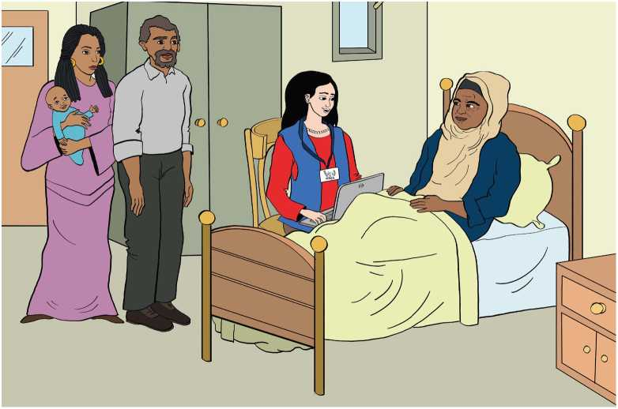

**Caritas**

W Egypt

010 2885 9666 Sunday - Thursday

010 2885 9777 '<-'09:00 - 17:00

Caritas provides individual and group counselling and psychosocial support for persons with disability and older persons. Assistive devices and life-quality improving materials and supplies (pressure­relieving mattresses, adult diapers, etc...) can be issued based on need. The project also facilitates access to necessary services, including rehabilitative therapy, through referral to specialized service providers. Additionally, social and recreational activities are regularly organized to promote the emotional well-being and social inclusion of persons with specific needs.

Nasr City

15 Mohammed Youssef Mousa, off Mostafa el-Nahas.

Al-Manteqa al-Oula.

PSYCHOSOCIAL SERVICES

Medecins Sans Frontieres (MSF)

Offers medical and psychological care to persons who have suffered sexual assault. Rape is a medical emergency. If you or someone you know has experienced sexual violence, call within 72 hours (3 days) to increase the chance for vital life-saving support. MSF also offers medical, physical and psychological rehabilitations for adult victims of traumatic events. Group support services are also available.

***MEDECINS SANS FRONTIERES DOCTORS WITHOUT BORDERS***

Maadi

No 2, Street 161 **Sunday - Monday**

Appointments

|  |  |
| --- | --- |
| **010 1215 9162**  **011 1148 3267** | **9:00 - 18:00** |
| EMERGENCY HOTLINE: 011 1708 3502 | **24 hours/7 days** |

Wednesday - Thursday

All MSF services are safe, confidential, respectable and free.

St. Andrews Refugee Services (StARS)

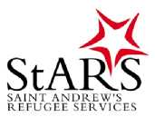Provides individual support activities, and education for children and**e**youth in Cairo who are not**t**accompanied by their parents; individual support for adults and families needing health, emotional, or social support; sporting activities and group support services.

Downtown

38, 26th of July St., Esaaf Square, Nasser Metro station **[info@stars-egypt.org](mailto:info@stars-egypt.org)**

**V.02 2773 6347 f St.Andrew'sRefugeeServices ©**

w

**UNHCR**

Terre des Hommes (TdH) Egypt

Provides psychosocial services: case management, positive parenting programmes and recreational activities through community-based protection and psycho-social centres.

**©**

**Sunday - Thursday 09:00 - 17:00**

6th of October City: Makany field office

6/8 Building, 1st Neighbourhood, 8th District

**V* 01099190279**

**01011255448**

Ain Shams: Darb Centre

|  |  |
| --- | --- |
|  | 5, El Masane' St., Off Mansheyet Elsad Elaaly St,  Off Gisr El Suez Road, behind Badr Garden |
| **V.** | **010 2169 8885**  **010 9141 1866** |

El Haram: Abwab Centres

|  |  |
| --- | --- |
|  | 3, Ibrahim El Gabri St., off Nasser El Thawra St. |
|  | **011 5119 9321** |
| **V.** | 52 El Taawon St., off El Haram St.  **011 1441 8132**  **01026723499** |

Obour City: Nawafez Centre

|  |  |
| --- | --- |
| **ft** | Metwally El Sharawy St., Behind El Yasmin Mall, |
|  | beside El Treeka Al Desokeya office  **010 1338 6156**  **011 4372 5571** |

LEGAL AID

United Lawyers

United Lawyers

United Lawyers provide legal assistance for all refugees and asylum­seekers. Services include: assisting in obtaining documentation such as birth, marriage, and divorce certificates. Representing the refugees before authorities and courts. United Lawyers assist in obtaining birth certificates for children born out of sexual and gender-based violence incidents. In addition to providing legal counselling, they also provide trainings and awareness sessions.

Maadi

13, St. 154, Maadi (Adham Tower), 1st Floor (Metro: Maadi)

**©Monday - Thursday 9:00 - 17:00**

**011 5452 6171**

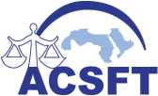Arab Council Supporting Fair Trial Human Rights (ACSFT)

Provides legal assistance for all refugees and asylum-seekers. Services include: assisting in obtaining documentation such as birth, marriage, and divorce certificates. Representing the refugees before authorities and courts. ACSFT assists in obtaining birth certificates for children born out of sexual and gender-based violence incidents. In addition to providing legal counselling, ACSFT also provides trainings and awareness sessions.

Agouza

30, 26th of July St., 4th floor

**010 2279 4411 Saturday - Thursday**

**10:00 - 18:00**

**Q UNHCR**

2?>l£2£!El£!E3!

Egyptian Foundation for Refugee Rights (EFRR)

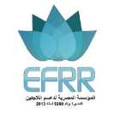Through its Access to Justice Team, EFRR provides legal assistance to refugees, including civil status support, legal aid, legal representation and specialised assistance for incidents related to sexual and gender­based violence (SGBV).

EFRR also provides legal assistance and advice to asylum-seekers and refugees, including unaccompanied minors, for initial RSD interviews and for those rejected in first instance and on appeal.

Downtown

2, Hussein El Ma'mar, 3rd Floor (off Mahmoud Bassiouny St.)

**©Sunday-Thursday 10:00 - 17:00**

**02 2575 1118**

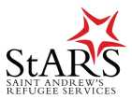St. Andrews Refugee Services (StARS)

Individual and family counselling and assessment services in relation to protection and vulnerability.

Downtown

38, 26th of July St., Esaaf Square, (Metro stop: Nasser) **[info@stars-egypt.org](mailto:info@stars-egypt.org)**

**St. Andrew's Refugee Services**

**02 2773 6347**

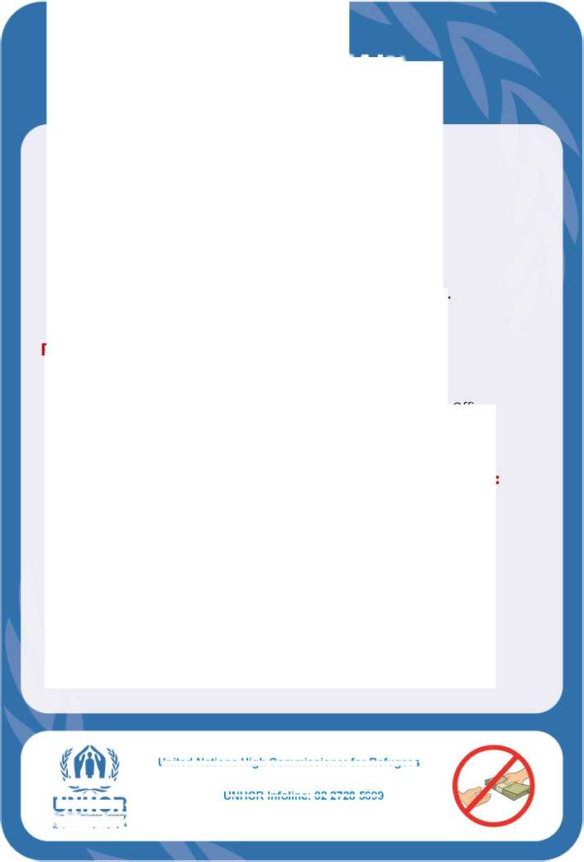HOW TO OBTAIN  
A BIRTH CERTIFICATE

United Nations High Commissioner for Refugees

UNHCR Infoline: 02 2728 5699

As an asylum-seeker or a refugee in Egypt,  
you need to obtain a birth certificate for your  
child within **14 days from date of birth.**

**HOW?**

The birth certificate is issued at the Health  
Office in the area where the birth took place.

**Required documents (ALL are required):**

* Valid and legally certified marriage or divorce documents;
* Birth notice by the hospital or any medical facility;

In case of delivery at home, you need to report to the Health Office;

* UNHCR registration card or valid passports of father and mother;
* Death certificate in case the father is deceased.

**Only the following persons can request a birth certificate:**

* Father
* Mother (with father's ID)
* An adult sibling from the father's side (with father's ID)
* A grandfather or an uncle from the father's side (with father's ID)

All newborn children MUST be registered.

All UNHCR services are free of charge.

UNHCR

**The UN Refugee Agency**

UNHCR INFOLINE: 02 2728 5699

Or

UNHCR's LEGAL PARTNERS:

• i [www.fb.com/UNHCREgypt](http://www.fb.com/UNHCREgypt)

If you do NOT have or possess the required documents,

If the father is not available or if you face any problems,

Please contact as soon as possible (best is three months before delivery).

Go to the Civil Registry Commission offices

If you did not obtain the birth certificate within 14 days,

The Arab Council for Supporting Fair Trials and Human

Rights (ACSFT)

Cairo: 010 2279 4411

Alexandria: 010 2299 0966

Damietta: 010 0670 1538

Required documents (ALL are required):

Valid marriage, or divorce document;

Birth notice by the hospital or any medical facility;

In case of delivery at home you need to report to the Health Office;

UNHCR card, or valid passports of father and mother;

Two pictures of the new born 4 x 6;

Application No. 26 (^ SjUM ): this application can be obtained

at any local registry office;

Death certificate in case the father is deceased.

**follow the below procedure:**

**of the Ministry of Interior**

UNHCR

**rhe UN Refugee Agency**

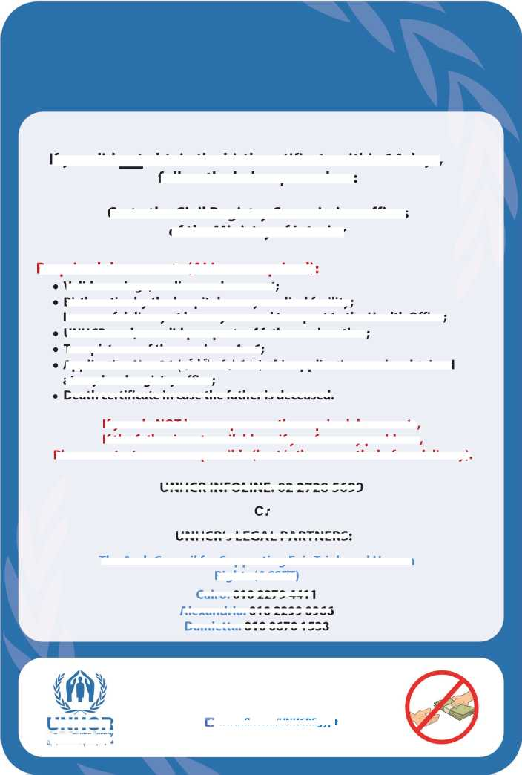

COMMUNITY CENTRES

Souriyat Community Centres for Women

Offers a variety of workshops and courses for Syrian refugee women.

*

ubjc^jj abulj

Souriyat Association

Heliopolis

"ft 19, Abdel Aziz Fahmy St.

**011 0004 9257**

10th of Ramadan City

"A Villa 64, El Ghandour Hospital St., 22nd Neighbourhood

**010 9221 7428**

**SouriyatAssociation.SY**

**O**

**Sunday - Thursday**

**09:00 - 15:00**

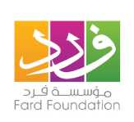

**Fardfoundation**

Fard Foundation

This programme aims to reach out to the most vulnerable refugee and host community members to identify their needs and provide life­enhancing services.

6th of October City

A Building 1, Block2/15, 12th District, Gharb Somid

**02 3838 4115**

**©Sunday - Thursday 09:30 - 16:00**

**CARD VALIDITY**



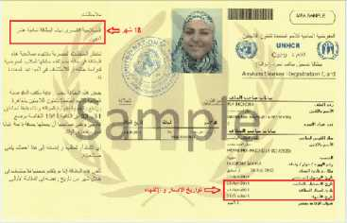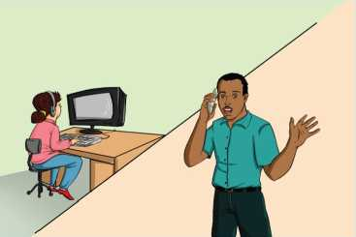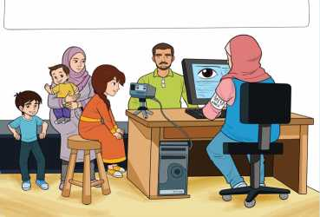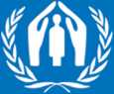

UNHCR

The UN Refugee Agency

The UNHCR asylum-seeker registration card (yellow card) is valid for 18 months while the UNHCR refugee registration card (blue card) is valid for three years. When your card expires, you need to renew it.

How do I renew my card?

Please contact the infoline at 02-2728 5699 during opening hours to book an appointment.

What happens if I do not renew my card?

Your case will be inactivated until you approach UNHCR again. You and your family will not be entitled to receive services and assistance from UNHCR and its partners.

**For further information please contact UNHCR Infoline:** Greater Cairo: 02 2728 5699

**n in Arabic on:**

@RefugeesEgyptAR

**in English & other languages:**

@ReOugeesEgypt

FREQUENTLY ASKED QUESTIONS

What happens if I do not renew my UNHCR documentation before it expires?

You and your family will not be entitled to receive services and assistance from UNHCR and its partners and your case will be deactivated until the moment you approach UNHCR again***.***

Why is UNHCR doing iris scanning?

• Every one of us has a unique iris and unique fingerprints.

• By recording your iris information and fingerprints upon your registration, UNHCR can avoid registering anyone more than once and thus protects your identity.

Why should I obtain a residence Permit?

Once you have received your asylum-seeker registration card (yellow card) or refugee registration card (blue card), you are obliged to obtain a legal residence permit (sticker) in order to legalise your stay in Egypt.

How can I close my file with UNHCR?

If you are registered with UNHCR and wish to withdraw your application, you should contact the Infoline to schedule your closure appointment. UNHCR would like to be provided with clear reasons for why you wish to close your file.

Can I apply for Resettlement?

No. Resettlement is not an application-based process. UNHCR continually reviews the situation of refugees in the most vulnerable situations to assess whether they meet UNHCR's resettlement criteria. If your case is under resettlement consideration, UNHCR will contact you.

Who should I approach in order to enrol my child in a school in Egypt?

You should approach the Student Affairs office of the Educational Administrative Zone in your area of residence with the following documents:

• A valid residence permit

• A previously recognized school certificate from the school your child attended before arriving to Egypt.

If you do not have any, your child must take the result of placement test, carried out by the Ministry of Education, which is free of charge for foreign students of all nationalities.

COMPLAINTS PROCEDURES

UNHCR's complaint procedures allow refugees and asylum seekers to  
file a complaint if there has been misconduct  
by UNHCR staff, interpreters, guards or NGO partners.

A complaint must be filed within 3 months of the incident.

Process to file a complaint

There is a complaint form available at all UNHCR offices if you wish to use it.

±  
a

**(A)**

Put your name and phone number on the complaint. Anonymous complaints will not be investigated.

Outline your complaint in as much detail as possible with dates, locations, witnesses.

Put the name or function or detailed description of the staff member, interpreter, guard or partner staff against whom the complaint is filed.

Unfounded or malicious complaints may lead to prosecution by the Egyptian * — authorities.

Queries or appeals for RSD or resettlement cannot be addressed through the complaints process.

UNHCR will ensure the confidentiality of the complaint process.

HOW TO FILE A COMPLAINT?

1- Through the office

3- By E-mail to

[ARECA@UNHCR.ORG](mailto:ARECA@UNHCR.ORG) and it will be forwarded to the UNHCR Egypt Representative.

Put the sealed envelope in the Complaints Box located in UNHCR office.

2- By post to

UNHCR Egypt Representative,

UNHCR, 17 Mekka El Mokarrama St. 7th District, 3rd Division, 6th of October City.

Complaint letters should be marked “Confidential.”

You will be notified within two months after submitting your complaint.

OTHER PARTNER UN ORGANIZATIONS

World Health Organization

WHO's primary role is to direct and coordinate international health **Organization** within the United Nations' system. The main areas of work are:

health systems, promoting health through the life-course, non­communicable diseases, communicable diseases, corporate services, preparedness, surveillance and response. WHO supports countries as they coordinate the efforts of multiple sectors of the government and partners, funds and foundations, civil society organizations and private sector, to attain their health objectives and support their national health policies and strategies.

United Nations Children's Fund

**UNICEF** and its partners support the Ministry of Health in its efforts to provide free and subsidised health care for refugees in Egypt, particularly the most vulnerable women and children. UNICEF collects feedback from beneficiaries to ensure continuous

**unicef**

improvements of available services. In the field of education, it supports the Ministry of Education in enhancing the capacity of public schools to accomodate Syrian children in quality learning environments.

International Organization for Migration

**IOM** works to help ensure the orderly and humane management of migration, to promote international cooperation on migration issues, to assist in the search for practical solutions to migration problems and to provide humanitarian assistance to migrants in need, including refugees and internally displaced people.

**International Organization for Migration (IOM)  
The UN Migration Agency**

**Q/1 W**

**-< /I UNHCR**

**Iha UN RalligM Agency**

Among its various activities, IOM operates a Resettlement Support Centre (RSC) for the Middle East and North Africa (RSC MENA) to conduct resettlement processing - free of charge - for the United States Refugee Admissions Programme in fifteen countries throughout the MENA region.

You may contact the RSC MENA Egypt Processing site: [www.jordan.iom.int/refinfo](http://www.jordan.iom.int/refinfo)

Hotline number: **19472** or by email at [ic@iom.int](mailto:ic@iom.int)

For other IOM Egypt services please call: **02 2736 5140/1/2**



UNFPA

UNFPA, in collaboration with CARE Egypt, offers psycho-social support in safe space settings, which includes assessment, emotional support, counseling, support for people with disabilities, community mobilization, conflict mediation, referral and protective housing support and various community activities for female refugees.

Nasr City

11, Ibrahim Nawwar St.

**Sunday - Thursday**

**09:00 - 17:00**

World Food Programme (WFP)

WFP

wfp.org

Provides food vouchers to the most vulnerable and food insecure Syrian refugees registered with UNHCR.

**WFP sends text messages to registered Syrian voucher recipients regarding the period during which the vouchers can be redeemed.**

**02 2528 2507**

Sunday - Thursday

09:00 - 15:00

**WFPassistancetosyrians**

**DONOR SUPPORT FOR UNHCR EGYPT 2018**

Austria

Canada

Denmark

Finland

France

European Union

german cooperation

the People of Japan

Netherlands

Sweden

"kJ,

UKaid

II

Italy ■|M Norway

United States of America

**TO ALL COUNTRIES,ORGANIZATIONSAND PRIVATEDONORS**

TO ALL COUNTRIES AND ORGANIZATIONS  
FOR THEIR GENEROUS CONTRIBUTIONS

**CONTACT DETAILS**

**UNHCR**

The UN Refugee Agency

**ZjLmXI 2lu3^2j«**

United Nations High Commissioner for Refugees

17 Makkah Al Mokramma St. 3rd Proximity, 7th District 6th of October City

@ RefugeesEgypt

UNHCR Infoline (Greater Cairo)

02 2728 5699

*@* UNHCRegypt

You

BE0

@ UNHCRegypt

Sunday - Thursday

8:30 - 15:00

